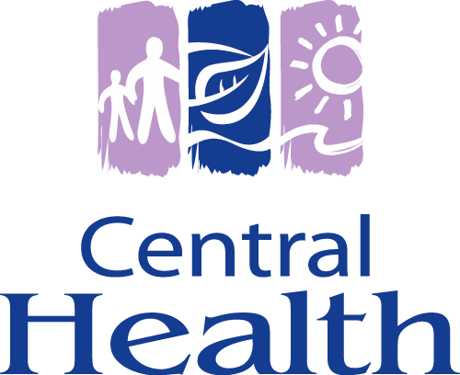

AN AGREEMENT RESPECTING THE CONFIDENTIALITY AND THE PROTECTION OF PERSONAL HEALTH INFORMATION BY HEALTH CARE PROFESSIONALS

INFORMATION SHARING AGREEMENT

BETWEEN Central Regional Health Authority, a Regional Health Authority established under the Newfoundland and Labrador Regional Health Authorities Act Health Authorities Act SNL2006 c R-7.1 (hereinafter referred to as Central Health)

AND [Insert Health Care Professional’s name]

___________________________________
(hereinafter referred to as the Health Care Professional)

(Each a “Party and collectively the “Parties”)

July 2013




Table of Contents

- Definitions 3
- Purpose of Agreement 5
- Authority for the Collection, Use and Disclosure of Personal Health Information 5
- Custodian of Personal Health Information 6
- Accountability 6
- Confidentiality and Privacy Policies 7
- Access to Central Health’s Clinical Information Systems 8
- Collection, Use and Disclosure of Personal Health Information 8
- Accuracy and Correction of Personal Health Information 9
- Security of Personal Health Information 10
- Contracts with Third Parties 10
- Auditing Access to Clinical Information Systems 11
- Retention of Personal Health Information 11
- Obligations of Notification of Privacy Breach 11
- Terms 12
- Indemnification 12
- General 12
- Survival 13
- Dispute Resolution 13
- Schedules 14
- Signature 15

Schedule A Policy 4-b-10 Confidentiality Policy
Schedule B Oath/Affirmation of Confidentiality
Schedule C Policy 4-g-10 Privacy Breach Policy
Schedule D System and Access Authorization Form
Schedule E Remote Access Authorization Form
Schedule F Policy 4-e-40 Disclosure of Personal Health Information to
Physicians for Billing Purposes
Schedule G Policy 4-h-20 Auditing Access to Clinical Information Systems

1. DEFINITIONS

1.1 In this Agreement:

  - “Access” means to retrieve information in any form for use or disclosure, including requests from clients to access or request correction to their personal health information;

  - “Agreement” means this Information Sharing Agreement outlining the rights, obligations and duties of the Health Care Professional in the management and security of confidential information;
  - “Authorized Personnel” means the Health Care Professional’s employees, associates, agents, contractors, subcontractors and affiliates (which term, for greater certainty, includes the affiliates’ employees, associates, agents, information managers and subcontractors);

  - “Breach” means any unauthorized collection, access, use, disclosure, copying, modification, retention or disposal of information subject to the Agreement;

  - “Central Health” means the Central Regional Health Authority as defined in the Regional Health Authorities Act, SNL2006 c R-7.1;

  - “Clinical Information Systems” means paper or electronic based information systems used to support clinical care;

  - “Collect” in relation to personal health information, means to gather, acquire, receive or obtain the information by any means from any source and "collection" has a corresponding meaning;

  - “Confidentiality” means an obligation to keep an individual’s personal health information private, ensuring that those authorized have access to the information;

  - “Confidentiality Policy” means Central Health’s Health Information Management and Privacy Policy No. 4-b-10, a copy of which is attached as Schedule ”A” to this Agreement;

  - “Custodian” as defined in the Personal Health Information Act SNL2008 c P-7.01 and as may be amended;

  - “Disclose” in relation to personal health information in the custody or control of a custodian or other person, means to make the information available or to release it but does not include a use of the information and "disclosure" has a corresponding meaning;

  - “Health Care Professional” means a person, including a corporation, which is licensed or registered to provide health care by a body authorized to regulate a health care professional under one of the following enumerated Acts but does not include an employee of a health care professional when acting in the course of his or her employment;

  - “HREAA” means Newfoundland and Labrador Health Research Ethics Authority Act SNL2006 c H-1.2;

  - “Information” means personal health information that is accessed, collected, used or disclosed for health care purposes and is the subject of the Agreement;

  - “Information Manager” means a person or body other than an employee of a custodian acting in the course of his or her employment, that processes, retrieves, stores or disposes of personal health information for a custodian, or provides information management or information technology services to a custodian;

  - “Limited Consent Directive” means the ability to withhold or withdraw consent for the collection, use or disclosure of one’s personal health information for a particular purpose, including for the provision of health care;

  - “Personal Health Information” as defined in the Personal Health Information Act SNL2009 c P-7.01 and as may be amended;

  - “PHIA” means the Newfoundland and Labrador Personal Health Information Act, SNL2008 c. P-7.01
  - “Processing” of personal health information means accessing, obtaining, recording or holding the information or carrying out any operation including organization, modification, retrieval, consultation or use, disclosure or otherwise making available through any medium, or alignment, combination, deletion or destruction of the information;
  - “Record” means a record of personal health information in any form, that is written, photographed, recorded or stored in any manner, but does not include a computer program or a mechanism that produces records on a storage medium;
  - “Security” means the methods used to protect personal health information from loss, or theft; or unauthorized access, use, copying, modification or disclosure. Technical, administrative and physical safeguards to ensure protection and integrity of confidential information.
  - “Use” means in relation to personal health information in the custody or control of a custodian, means to handle or deal with personal health information or to apply the information for a purpose and includes reproducing the information, but does not include disclosing the information.

2. PURPOSE OF AGREEMENT

2.1 The purpose of this Agreement is to define the parameters and accountabilities for the
secure management and handling of personal health Information (hereinafter referred to as Information) contained within Central Health’s electronic and paper clinical information systems obtained by the Health Care Professional through affiliation with Central Health. This Agreement covers Information disclosed by Central Health for the purpose of providing optimal and timely care.

2.2 This Agreement includes measures to:

- ensure compliance with the statutory requirements for the disclosure of Information;
- establish accountability for the secure lifecycle management and privacy of
Information obtained through affiliation with Central Health;
- ensure robust administrative, physical and technological security measures are implemented by the Health Care Professional consistent with Central Health information security policies and standards;
- ensure the integrity, security and protection of the Information is not compromised by any sharing or disclosure of Information exchanged under this Agreement; and
- establish the accountability for authorized access and the secure management of Information by third parties including Authorized Personnel of the Health Care Professional.

3. AUTHORITY FOR THE COLLECTION, USE AND DISCLOSURE OF PERSONAL HEALTH INFORMATION
3.1 Central Health is authorized to collect, use and disclose Information pursuant to the following statutes and subject to professional practice standards:

  - Personal Health Information Act SNL2008 c P-7.01;
- Regional Health Authorities Act RSNL2006 c R.7.1;
- Medical Care Insurance Act RSNL1999 c M-5.1; and
- Other provincial and federal legislation.

3.2 The Health Care Professional is authorized to collect, use and disclose the Information
pursuant to the following statutes and subject to professional practice standards:

  - Personal Health Information Act SNL2008 c P-7.01;
- Medical Care Insurance Act RSNL1999 c M-5.1; and
- Other provincial and federal legislation.

3.3 Each Party shall notify the other in writing of any changes in legislation or regulations that may affect the implementation of the Agreement.

4. CUSTODIAN OF PERSONAL HEALTH INFORMATION

4.1 The Health Care Professional assumes custody and control of Information subject to this Agreement including duties and obligations under legislation.

4.2 The Health Care Professional does not cease to be a custodian of Information until
complete custody or control of the Information, where applicable, passes to another individual who is legally authorized to hold the Information and the duties imposed on a custodian.

5. ACCOUNTABILITY

5.1 Each Party is responsible for the secure management and integrity of the Information under its custody or control.

5.2 When the Information that is the subject of this Agreement is accessed by the Health
Care Professional, Central Health is accountable:

- to the point Information is accessed by the Health Care Professional through Central Health’s secure internal network or records management processes;

- at the point of disclosure, transfer or transport of Information in paper or electronic format from Central Health’s clinical information systems to the Health Care Professional, through any medium;

- to ensure the integrity, availability, support and maintenance of internal clinical information systems of Central Health; complete with audit trails and industry standard security protocols and safeguards;

- in the event of a declaration of a consent directive by a client of Central Health; Central Health shall take reasonable measures to inform the Health Care Professional of the limitation(s) on consent for collection, use and disclosure of the Information;

- to ensure that the Health Care Professional is familiar with the privacy requirements as outlined in Central Health’s Confidentiality Policy and Information Management and Technology access authorization forms;

- to conduct auditing protocols in electronic and paper format of the Health Care Professional and any of their Authorized Personnel that have access to Central Health’s clinical information systems; and

- to ensure that upon notification of termination of affiliation with Central
Health, access to Information is terminated for the Health Care Professional and any of their Authorized Personnel that no longer require access.

When the Information that is the subject of the Agreement is accessed by affiliation with Central Health, the Health Care Professional is accountable:

- to ensure familiarity with the privacy requirements as set forth in the Agreement and all applicable statutes and regulations;

- to enter into a binding Agreement with Central Health to ensure secure management of Information, throughout its lifecycle, obtained through affiliation with Central Health;

- to declare and implement a robust information security framework to ensure protection of Information accessed through affiliation with Central Health;

- to ensure the information security measures and procedures including operating systems and portable data storage devices implemented by the Health Care Professional meet or exceed the accepted security standards of Central Health;

- to ensure accountability measures and safeguards are implemented for their Authorized Personnel in the management of the Information obtained through affiliation with Central Health;

- in the event of a privacy breach, to cooperate fully and assist in any civil or other investigations carried out by Central Health, or a person or body with legislative authority to conduct such an investigation involving the Information; and

- to ensure that upon termination of affiliation with Central Health , the Health Care Professional or any of their Authorized Personnel with approved access to Information through Central Health’s clinical information, will notify Central Health to this effect, in order to have access terminated.

6. CONFIDENTIALITY AND PRIVACY POLICIES

6.1 All Information accessed through or disclosed by Central Health to the Health Care
Professional must continue to meet or exceed the level of Information protection established by Central Health.

6.2 In addition to any legislative requirements, the Health Care Professional shall comply with confidentiality and privacy policies, and the Oath of Central Health which hosts the Information being disclosed.

6.3 The Health Care Professional will ensure all of their Authorized Personnel are aware of their obligations under the Personal Health Information Act (PHIA) and enter into a binding confidentiality agreement which survives any affiliation with Central Health.

6.4 By signing the Agreement, the Parties agree to uphold and comply with the principles in the Agreement.

6.5 In the event of termination of the Agreement, the Information shared under this Agreement shall remain confidential.

7. ACCESS TO CENTRAL HEALTH’S CLINICAL INFORMATIONS SYSTEMS

7.1 All Health Care Professionals and any of their Authorized Personnel authorized to access Information through one of Central Health’s clinical information systems must complete the following prior to being granted access:

- review in its entirety Central Health’s Confidentiality policy (Schedule “A”);
- review and sign an Oath / Affirmation of Confidentiality (Schedule “B”);
- review and sign the System and Access Authorization Form (Schedule “D”); and
- review and sign the Remote Access Authorization Form (Schedule “E”).

7.2 A unique user identification and password grants authorized and authenticated role based access to Central Health’s clinical information systems. It is the responsibility of each user to ensure integrity and confidentiality of the Information contained in any clinical information system of Central Health, as per Central Health’s Confidentiality policy.

7.3 The Health Care Professional must ensure any of their Authorized Personnel accessing Central Health’s clinical information systems are able to access only the Information necessary for their role; each individual responsible to the Health Care Professional is appropriately trained; enter into a confidentiality agreement (Oath or affirmation) for issue of a unique user identification and secure password; and are aware of and comply with all data protection policies and procedures of Central Health.

7.4 Any misuse, inappropriate access or failure to safeguard Information may be cause for disciplinary action up to and including:

termination or suspension of contract or loss of privileges or affiliation with Central Health;

report to the Health Care Professional’s regulatory body; or

civil action in accordance with the Personal Health Information Act or criminal prosecution in accordance with provincial and federal legislation.

7.5 It must be understood that all access to these systems will be monitored and suspected breaches of confidentiality will be investigated.

8. COLLECTION, USE AND DISCLOSURE OF PERSONAL HEALTH INFORMATION

8.1 The Health Care Professional will collect, use and disclose Information in accordance with:

- this Agreement;
- the Personal Health Information Act and other relevant legislation and applicable law;
- recommendations of the Information and Privacy Commissioner of Newfoundland and Labrador;
- Ministerial orders;
- practice standards of the Newfoundland and Labrador College of Physicians and Surgeons;
- court orders; and
- client’s consent.

8.2 The Health Care Professional agrees to only collect, use or disclose the Information for
purposes such as:

- to identify an individual who needs or is receiving health care;
- to provide health care to or facilitate the care of an individual;
- to manage chronic disease; and
- to facilitate health insurances and MCP billing.

8.3 Information obtained through affiliation with Central Health must not be collected, used or disclosed for a different purpose other than outlined in this Agreement without informing and obtaining the consent of the individual who is the subject matter of the Information, approval of Central Health, or otherwise required by law.

8.4 The Health Care Professional recognizes that as per Section 44 of the PHIA that any Information under this Agreement used for the purpose of research requires approval by a research ethics board or research ethics body under the Health Research Ethics Authority Act (HREAA) and Central Health.

8.5 The Parties will keep confidential the Information and will not disclosure it to a third party unless such disclosure is:

- necessary to meet a purpose permitted in;
- otherwise required by law; or
- to an authorized information manager.

8.6 The Parties will not copy or duplicate the Information in any manner unless such
copying or duplicating is necessary to meet an authorized purpose.

8.7 The Health Care Professional recognizes that one of the permitted use of Information
outlined in PHIA is for the purpose of obtaining payment for the provision of health care (billing). Where a Health Care Professional obtains copies of Information for the purpose of billing, the Health Care Professional becomes the custodian of that Information and is assuming full responsibility and accountability for the secure management, the appropriate use and disposal of the Information. Refer to Policy
4-h-20 Disclosure of Personal Health Information for Billing Purposes (Schedule F).

9. ACCURACY AND CORRECTION OF PERSONAL HEALTH INFORMATION

9.1 The Parties recognize that accurate Information is required to provide optimal and
timely health care. Each Party will notify the other Party if any changes are required to the Information.
9.2 Where a Health Care Professional receives a request from a client for correction to the Information that is the subject of this Agreement, the Health Care Professional is to direct the request to the Health Information Management and Privacy Department at the specific facility for processing, as per Central Health’s policy.

9.3 Where a request for correction to Information is approved, Central Health must provide written notice of the correction to a person to whom Central Health has disclosed the Information within a twelve (12) month period immediately preceding the request for correction, unless:

- Central Health reasonably believes that the correction or amendment will not have an impact on the ongoing provision of health care or other benefits to the individual; or
- where the individual requesting the correction or amendment has advised that notice is not necessary.

9.4 Upon notification of a perceived inaccuracy, Central Health will take reasonable steps to investigate the inaccuracy, correct it where necessary and notify the other Party of the steps taken.

10. SECURITY OF PERSONAL HEALTH INFORMATION

10.1 The Health Care Professional must implement robust security measures for the protection of Information in its custody or control obtained through affiliation with Central Health. The information security framework shall defend against such risks as unauthorized access, collection, use, disclosure, storage, modification, and/or disposal of the Information. These security measures, policies and standards shall:

    - meet or exceed any applicable Information security policies published,
adopted or endorsed by the Government of Newfoundland and Labrador.

10.2 The Health Care Professional must ensure administrative, physical and technical safeguards are implemented to protect the Information appropriate to the degree of sensitivity and harm which could result from a breach of security. Information and its physical storage devices must be protected from corruption, deletion, modification and unauthorized access use or disclosure.

11. CONTRACTS WITH THIRD PARTIES

11.1 The Health Care Professional must ensure all any of their Authorized Personnel and any contracted third parties including information managers, exposed to the Information of Central Health are aware of and comply with their obligations under legislation; enter into a binding confidentiality or information sharing agreement with the Health Care Professional; and implement robust security measures equivalent to the information security standards of Central Health for the protection of Information obtained through affiliation with Central Health.

11.2 The Health Care Professional must implement a privacy breach protocol with all third parties and affiliated individual(s) that mandate immediate notification to the Health Care Professional where any Information obtained through affiliation with Central Health is lost, stolen, used, modified, disposed or accessed, used or disclosed in an unauthorized manner.

12. AUDITING ACCESS TO CLINICAL INFORMATION SYSTEMS

12.1 All access to Central Health’s clinical information systems are subject to routine and requested auditing with prudent investigation of all suspected or identified privacy incidents.

12.2 The Parties will not permit anyone to access, store or use the Information unless that individual is an authorized and credentialed user of Central Health’s clinical information systems.

12.3 Central Health will maintain a record identifying each authorized user. The Information accessed by an authorized user shall be limited to that which is necessary to fulfill his or her job function, consistent with the purposes and terms of this Agreement.

12.4 The Health Care Professional agrees to ensure that any and all individual(s) responsible to the Health Care Professional are informed that access to Central Health’s clinical information systems is audited on a routine and requested basis.

12.5 The Health Care Professional shall ensure that all individuals responsible to the Health Care Professional that their access to Central Health’s clinical information systems are aware that their access to Information shall be limited to that which is necessary to fulfill his or her job functions.

13. RETENTION OF PERSONAL HEALTH INFORMATION

13.1 The Health Care Professional will retain the Information in accordance with provincial policy and standards of the College of Physicians and Surgeons of Newfoundland and Labrador.

14. OBLIGATIONS OF NOTIFICATION OF PRIVACY BREACH

  - Under the terms of the Agreement, the Health Care Professional shall immediately notify Central Health’s Privacy Manager in the event of any alleged, suspected or actual breach of Information, including loss, theft, destruction, corruption, modification, unauthorized access/collection/use/disposal/disclosure of Information, compromised clinical information systems or portable data storage devices containing Information of Central Health through affiliation with Central Health;

14.2 Each Party will be responsible for notifying the individual(s) affected by the breach and the Office of the Information and Privacy Commissioner where a privacy breach occurs within the Party’s area of accountability.
14.3 The Health Care Professional shall bear their own costs (including legal costs) in cooperating with Eastern Health in any investigation involving a breach of Information that is the subject of this Agreement.

15. TERMS

15.1 The term of this Agreement will begin on the date the Agreement is signed and dated by the Health Care Professional and Central Health (hereinafter referred to as Parties).

15.2 Provided this Agreement is not terminated earlier, the Agreement may be renewed upon written Agreement of the Parties on substantially the same terms and conditions herein.

15.3 Each Party will be responsible for its own costs associated with the implement of this Agreement.

15.4 Either Party may terminate this Agreement by providing written notice to the other Party, thirty (30) days in advance of the proposed termination date.

15.5 Notwithstanding anything contained in this section, Central Health may immediately and in its sole discretion suspend or terminate this Agreement and/or any user’s access to the Information; (i) if Central Health believes that that the confidentiality and security of the Information has been compromised, or the Health Care Professional or any of their Authorized Personnel has breached the Agreement; (ii) if any of Central Health’s underlying rights necessary for it to provide the Information are terminated; (iii) if Central Health, in its sole discretion, elects to discontinue offering the Information; or (v) in the event of a change in organizational representative.

16. INDEMNIFICATION

16.1 The Health Care Professional will defend, indemnify and hold harmless Central Health in respect to any and all claims (including third party claims) losses, damages, suits, actions, causes of action, costs and/or expenses including legal fees and disbursements and court costs, and/or liability, of any kind whosever resulting directly from or relating to the access to the Information and/or unauthorized access, collection, use, disclosure, copying, modification, disposition, loss or retention to the Information; any breach of this Agreement including without limitation the breach of any representation or warranty, or any act or omission of the Health Care Professional or any of their Authorized Personnel; or the failure of the Health Care Professional to comply with the terms of this Agreement.

16.2 This indemnity will survive the termination of this Agreement.

17 GENERAL

17.1 This Agreement shall be governed by the laws of the Province of Newfoundland and
Labrador, without regard to conflict of laws. Any dispute that may arise under this Agreement shall be resolved in the Province of Newfoundland and Labrador.

17.2 This Agreement, including the attached “Schedules” to be executed pursuant hereto, constitutes the entire Agreement between Central Health and the Health Care Professional relating to the subject matter of this Agreement and supersedes all prior agreements, understandings, and negotiations, whether written or oral, between the Parties with respect to the subject matter of this Agreement.

17.3 Except as otherwise specifically provided herein, the specific rights and remedies of either Party under this Agreement are cumulative and not exclusive to any other rights or remedies to which either Party may be entitled under this Agreement, at law or in equity, and the Parties will be entitled to pursue any and all of the respective rights and remedies concurrently, consecutively and alternatively.

17.4 Except as otherwise permitted under its terms, this Agreement shall not be modified or amended except in written instruments agreed to and signed by the Parties.

  - Any amendment to this Agreement will only be effective from the date of approval.

17.6 Any notice, document, statement, report or demand that may be required of any Party under the Agreement will be in writing to designated representatives listed in Section 19 of the Agreement.

  - No Party will be deemed to have waived the exercise of any right unless such waiver is expressed in writing.

  - This Agreement may be executed in counterparts, each of which so executed will be deemed as an original, and such counterparts together constitute one and the same instrument. Delivery by facsimile or by electronic submission in portable document format (PDF) of an executed counterpart of this Agreement is as effective as delivery of an originally executed counterpart of this Agreement. If delivered by facsimile or PDF, the Health Care Professional must also promptly send an executed original by courier to Central Health.

- SURVIVAL

18.1 Sections 4 through 19 shall survive termination of the Agreement.

19. DISPUTE RESOLUTION

19.1 Any new issue, amendment, matter of general concern or dispute arising from this Agreement shall be directed to the designated representatives listed below for resolution.

For Central Health – V. P. of Medical Services
The Health Care Professional – as identified as per page 1 of this Agreement
19.2 If not resolved within thirty (30) days, it will be a matter for consultation and resolution between the designated representatives.

20. SCHEDULES

20.1 Schedules A, B, C, D, E, F and G attached hereto form part of this Agreement as set forth herein.

SIGNATURE PAGE FOLLOWS

21. SIGNATURES OF AUTHORIZATION

IN WITNESS WHEREOF, the Parties have executed this Agreement,

Health Care Professional

Per: ______________________________________________

Name (Please Print); ________________________________

Title: ___________________________________________

Mailing Address: __________________________________

Telephone Number: ________________________________

E-Mail Address: ____________________________________

Date: ____________________________________________

Central Health

Name: __________________________________________

Title: ____________________________________________

Signature: _______________________________________

Date: ___________________________________________

SCHEDULE “A”

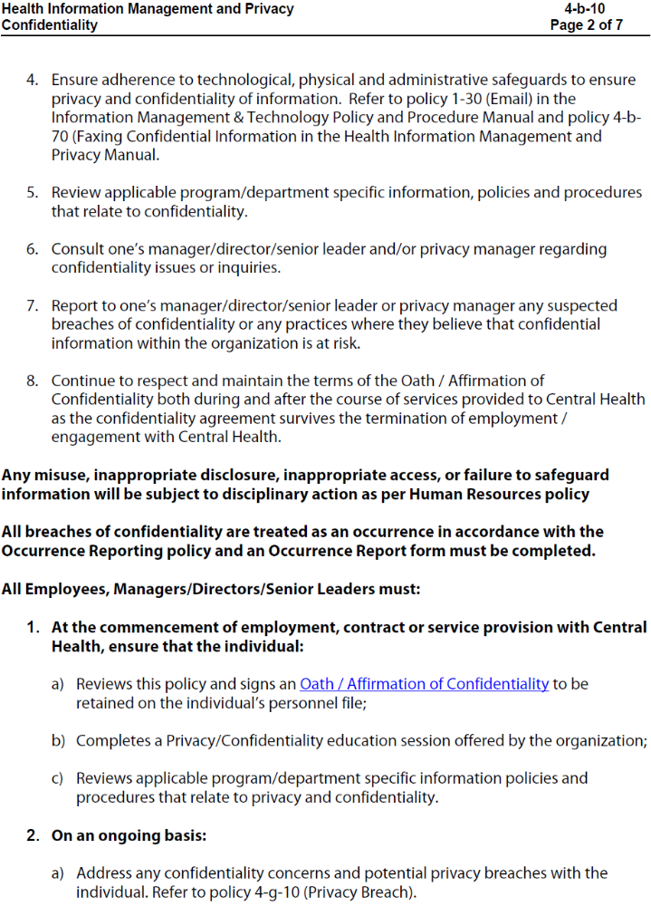
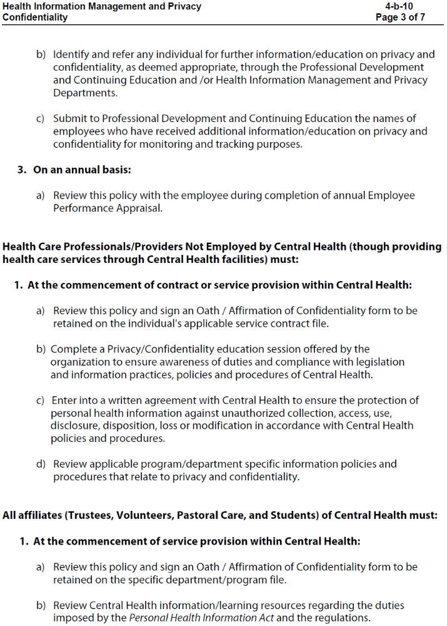
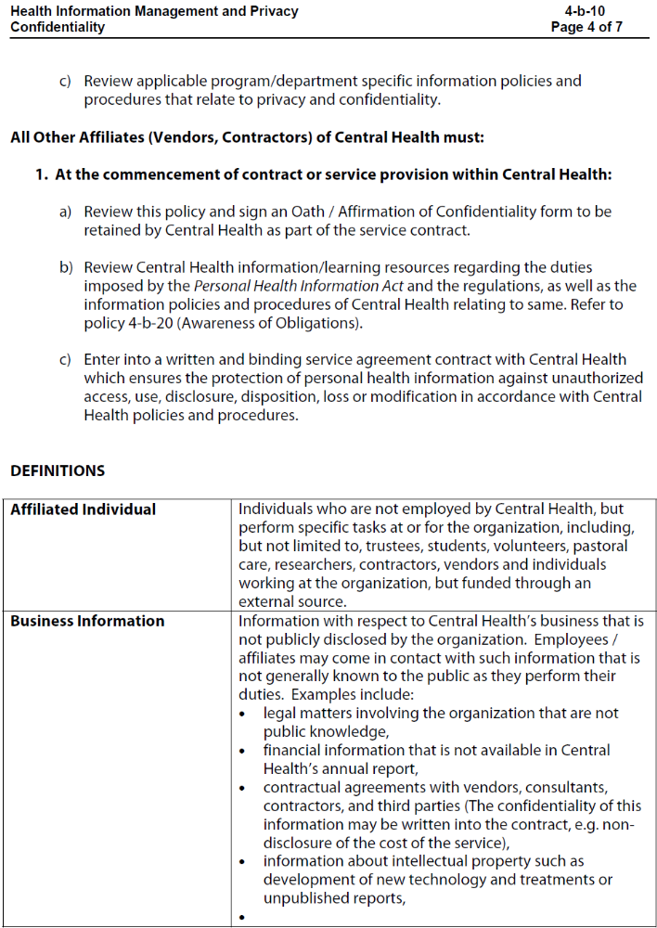
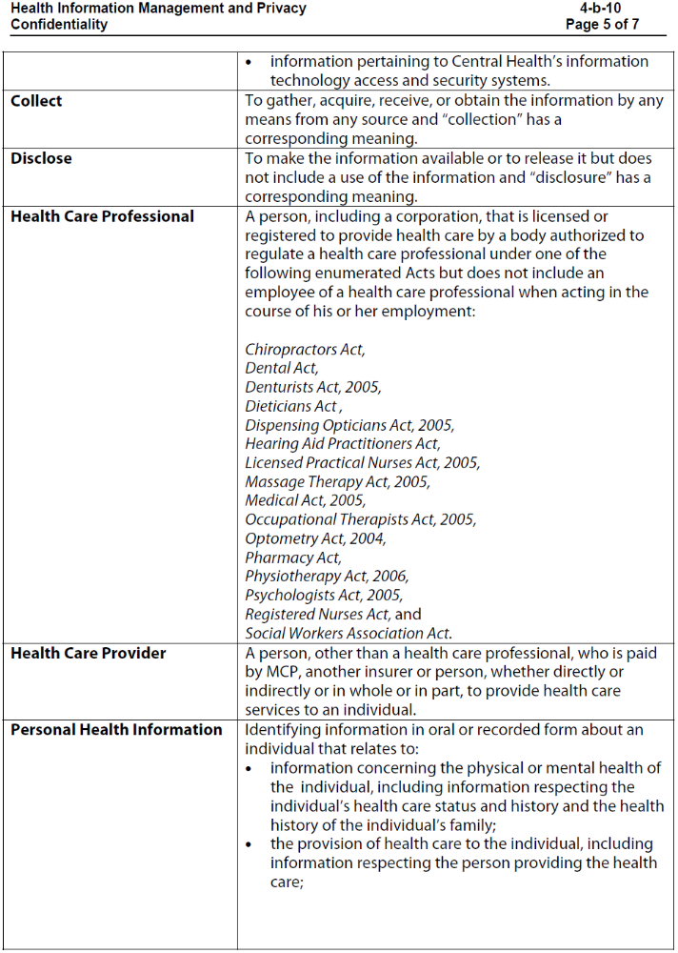
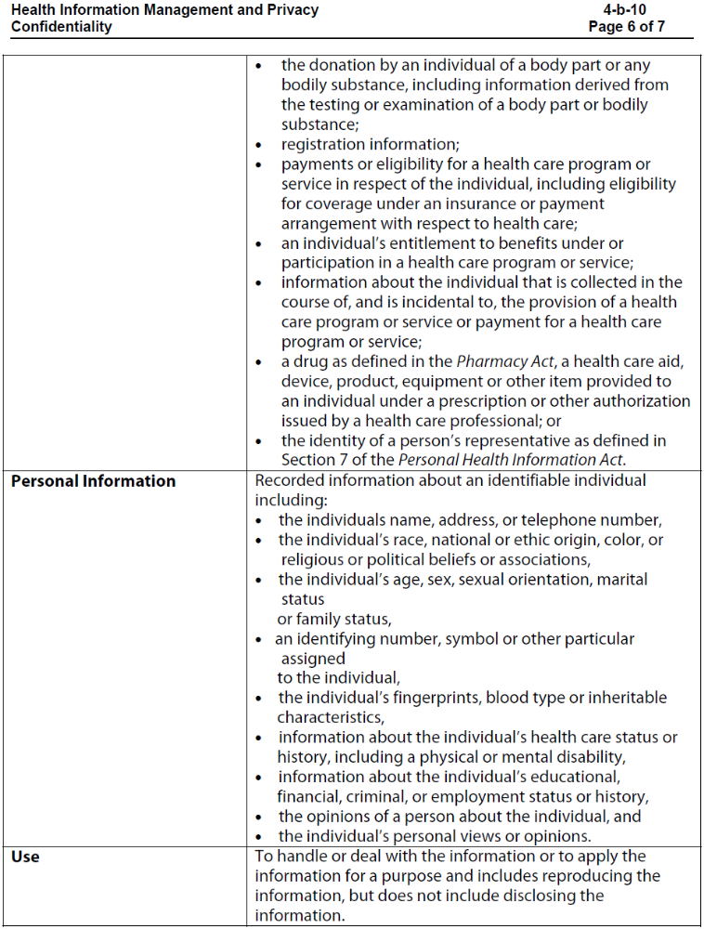
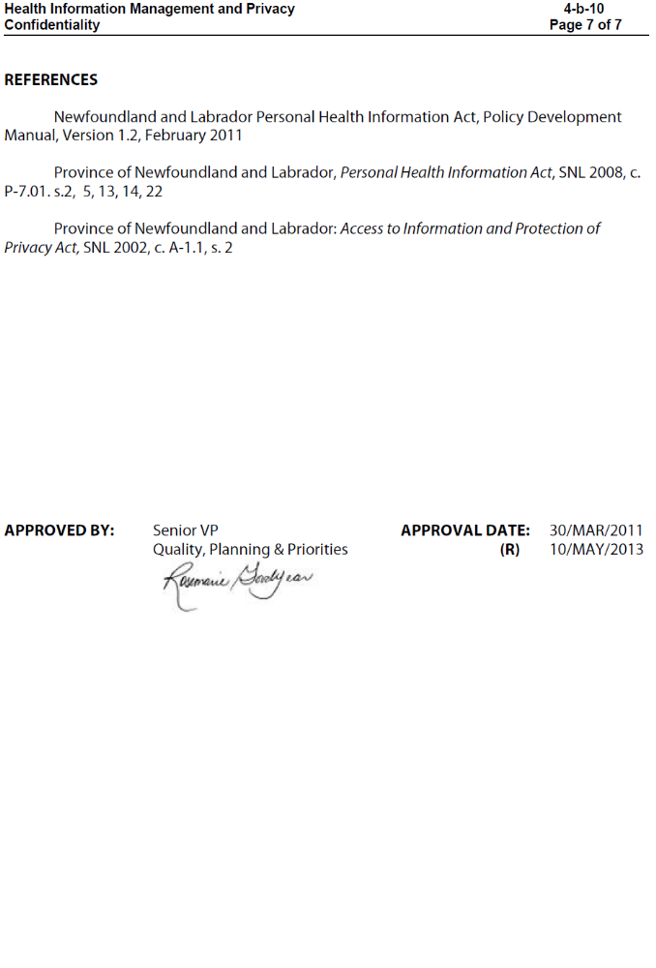
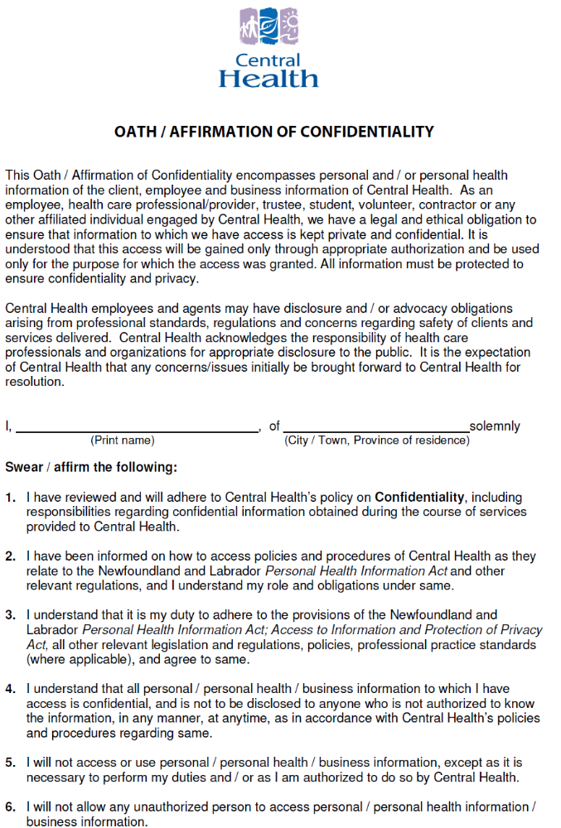
SCHEDULE “B”
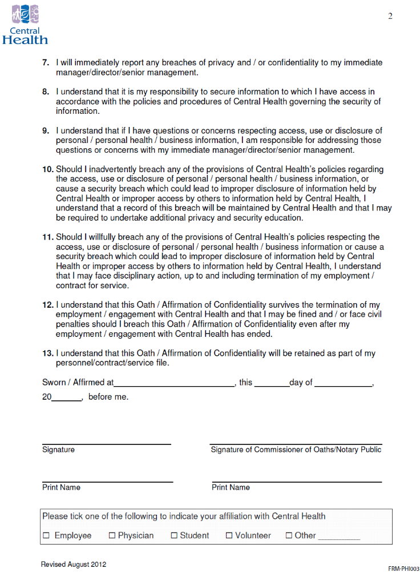
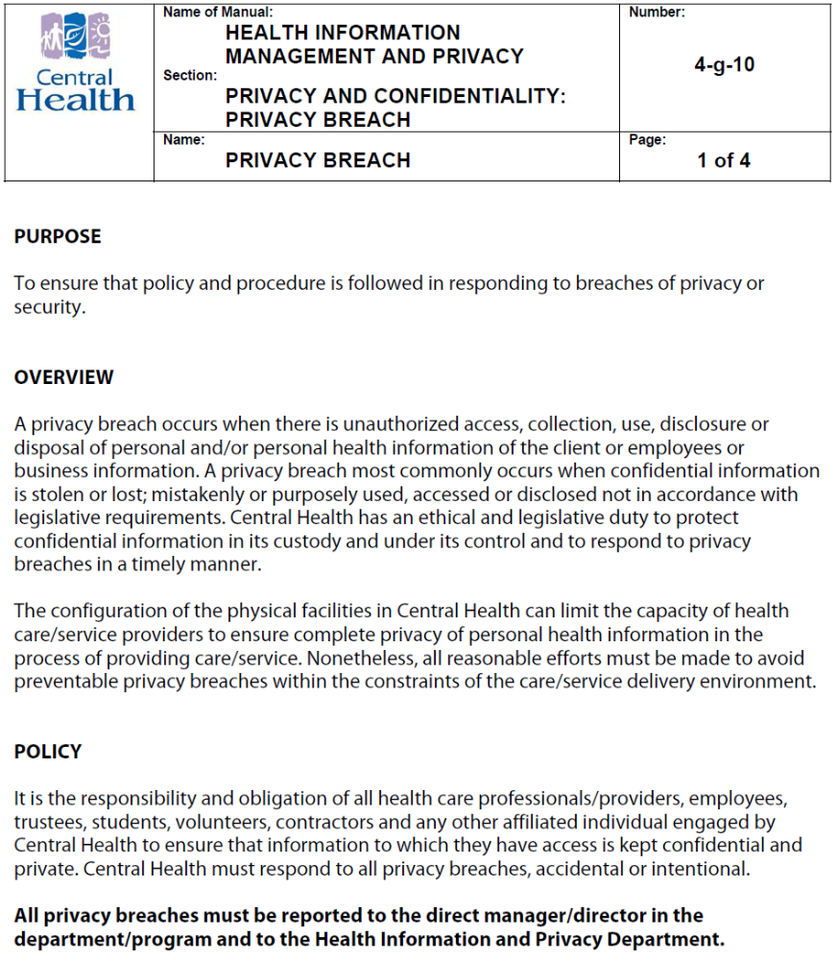
SCHEDULE “C”
SCHEDULE “D”
SCHEDULE “E”
SCHEDULE “F”
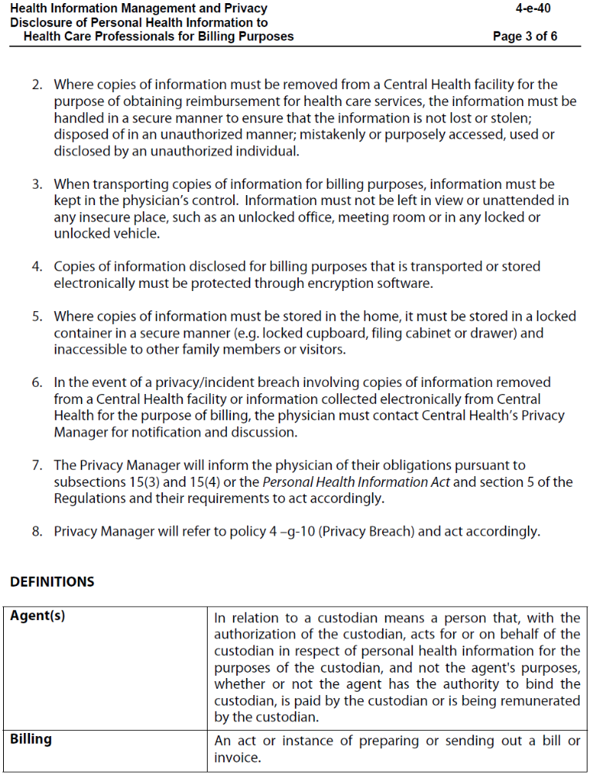
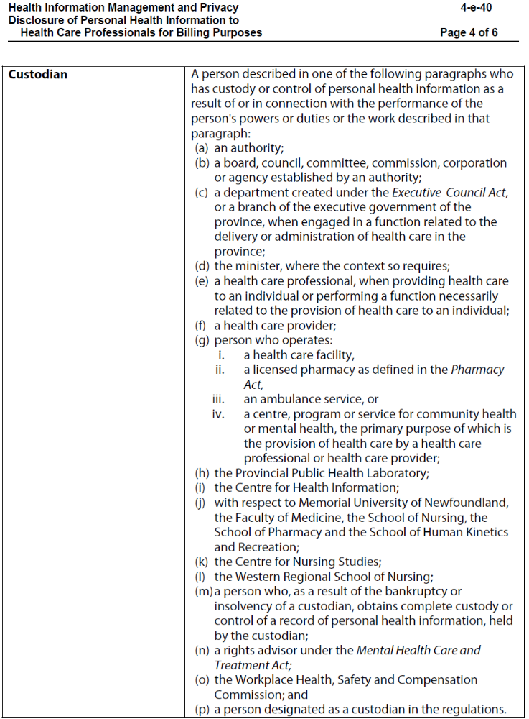
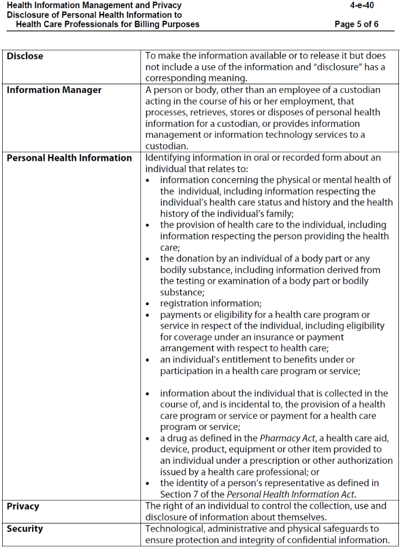
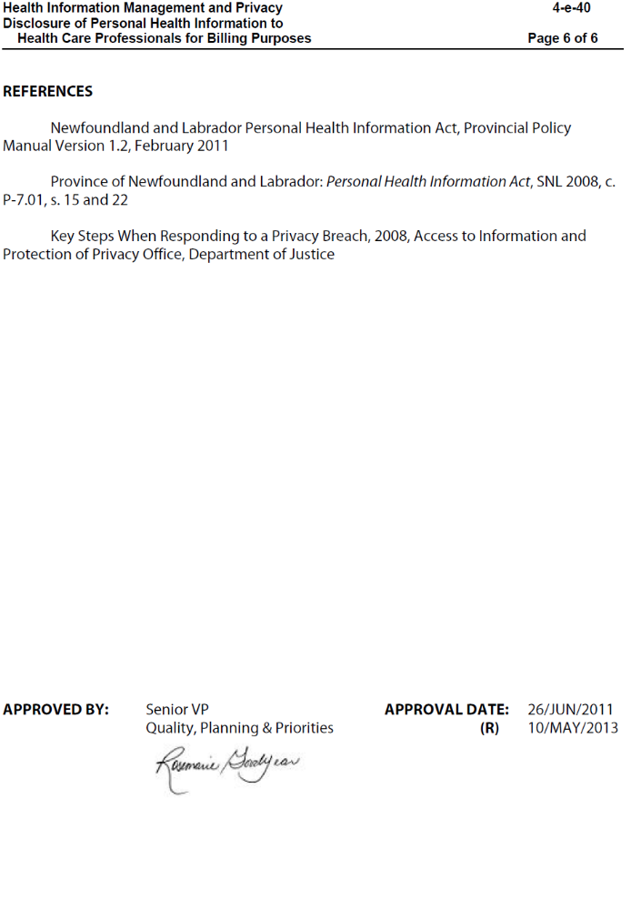
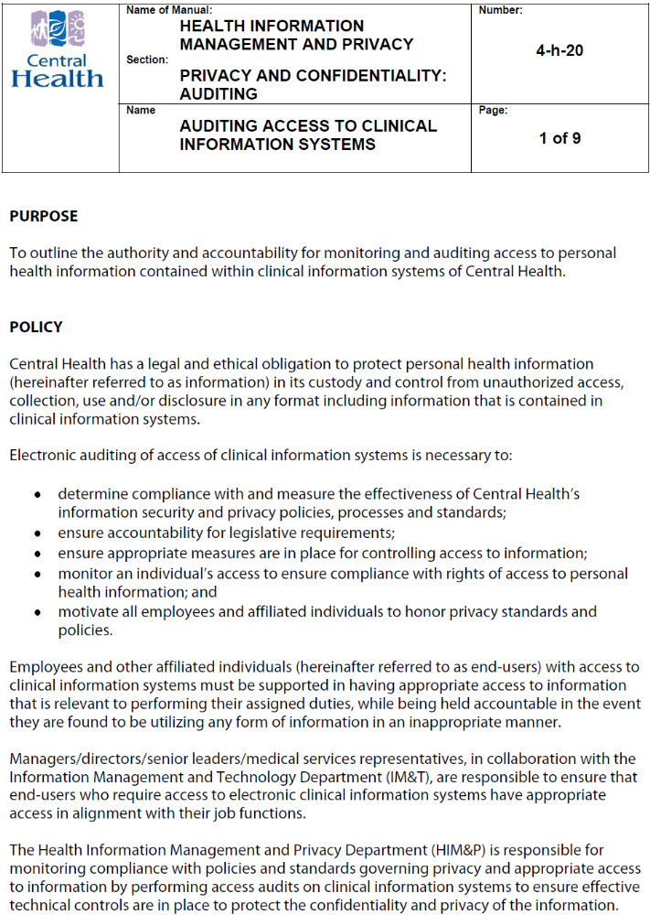
SCHEDULE ‘G’


